S.S.E.S. Amravati’s Science College Congress-Nagar, Nagpur
Department of Physical Education
ANNUAL REPORT- (2022-2023)
(DEGREE-COLLEGE)
I am very glad to submit the Annual Report of sport Activities conducted during the academic session 2022-2023. The unique record of success of the college is well known all over Vidarbha. The achievement the students in the field of sports and their all round development reflected through the prizes are the hallmark of institutional glory. I take an opportunity to present the report of their spectacular achievements. The college students participated in the following Games in District, Division, State, National, University, and Inter-University Tournaments.
DEGREE COLLEGE:-
Participations: 17 Men & 16 Women Team were participated in various games & Sports of R.T.M. Nagpur University.
Men :- Fencing Base-Ball, Mini Golf, Soft-ball, Power-Lifting, Karate, Cricket,Foot-ball, Athletics, Basket- Ball, Judo, Korf -ball, Archery, Boxing,Wrestling, Taekwondo Gymnastics.
Women : - Fencing, Hockey, Hand- Ball,Taekwondo, Sepak– Takraw, Base-Ball, Mini Golf, Cricket,Volley Ball,Wood ball,Soft Ball,Archery,Yogasan, Athletics, Gymnastic, Korf –ball
Inter colligate Soft ball (women) Tournament RTM Nagpur University.-2022-2023
Department of physical education Inter Collegiate soft ball (women)Tournament 2022-2023 during 09/03/2023 to 11/03/2023 in Which 27 team has participated S.S.E.S.A’S Science College, Nagpur awarded first prize winner team of Kamala Nehru college Nagpur, Second Prize winner team of Sindhu Mahavidyalaya Nagpur and third Prize winner S.S.E.S.A’ S Science college congress nagar , Nagpur at the hands of principal Science college, Nagpur Prof Mahendra P. Dhore.
SECLECTED PLAYERS IN ALL INDIA INTER UNIVERSITY
FENCING(Men):- Ku. Harshada G. Damkondawar M.Sc.–I (Micro) Participated in All India Inter University Competition This event was held from 20/12/2022 to 23/12/2022 at JAMMU Organized by UNIVERSITYOF JAMMU.

FENCING (Women):- Ku.Vidnyani N.Umathe B.Sc –III (SCsM) Participated in All India Inter University Competition. This event was held from 20/12/2022 to 23/12/2022 at JAMMU Organized by UNIVERSITYOF JAMMU.

FENCING(Men):- Mr. Aditya R. Selokar B.Sc.–II (CGM) Participated in All India Inter University Competition This event was held from 20/12/2022 to 23/12/2022 at JAMMU Organized by UNIVERSITYOF JAMMU.

HOCKEY(Women):- Ku. Anishka Sunil Admane B.Sc.III (PCM) Participated and selected in All India Inter university hockey (women) competition This event was held from 26/12/2022 to 30/12/2022at UDAIPUR Organized by JANARDAN RAI NAGAR RAJASTHAN VIDYAPEETH

HAND-BALL(Women):- Ku. Arya P. Dumbhare B.Sc.-II(CMBT) Participated and Selected in All India Inter University Hand Ball Competition Which was held at SAGAR Organized by MAHARAJ CHHATRASAL BUNDALKHAND UNIVERSITY. This event was held from 27/12/2022 to 31/12/2022

TAEKWONDO (Women):-Ku. Akanksha K. Kirpan B.Sc. –II(ECSM) she was Selected in All India Inter University Taekwondo Competition This event was held from AMRITSAR Organized by GURU NANAK DEV UNIVERSITY dated on 09/02/2023 to 12/02/2023.

SEPAK-TAKRAW (Women):- Ku.Avantika G.Lokhande B.Sc.– III (ECsM) She Selected in All India Inter University Sepak-Takraw Competition. This event was held fromCHANDIGARH Organized by PANJAB UNIVERSITY. Dated on 13/02/2023/ to 15/02/2023.

BASE-BALL(Men): Mr.Nikhil Tembhurne M.Sc-I(C/S) and Anup S.Tiwari B.Sc.-II (CMBT) was Selected all India Inter University Base Ball Competition This event was held from GUWAHATI Organized by THE ASSAM ROYAL GLOBAL UNIVERSITY. On dated 14/02/2023/ to 18/02/2023.

BASE-BALL(Women):- Ku. Nidhi V. Khambalkar B.Sc. II (PCsM) was Selected in All India Inter University Base Ball Competition Which was held at GUWAHATI Organized by THE ASSAM ROYAL GLOBAL UNIVERSITY. This event was held from 24/02/2023/ to 28/02/2023.

MINI GOLF (Men): - Mr. Anup S.Tiwari B.Sc.-II (CMBT) was Selected in All India Inter University Mini Golf Competition Which was held at JAIPUR Organized by SURESH GYAN VIHAR UNIVERSITY This event was held from 01/03/2023/ to 05/03/2023.

MINI GOLF (Women): - Ku. Poonam P. Khope B.Sc.-III (CBZ) She was Selected in All India Inter University Mini Golf(Women) Competition Which was held at JAIPUR Organized by SURESH GYAN VIHAR UNIVERSITY. This event was held from 01/03/2023/ to 05/03/2023.

CRICKET (Womn) : - Ku.Kushi M.Bhagat B.C.A.-I She was a Selected All India Inter University Cricket Competition held at BHUBANESHWAR Organized by . KALINGA INSITITUTE OF INDUSTRIAL TECHNOLOGY This event was held from 10/03/2023 to 18/03/2023.

KORF-BALL (Combin):-Mr. Rohan K. Nimje B.Sc.-II(SCsM) and Ku. Vedanti D. Wakulkar B.Sc.-I (CMBT) was a Selected All India Inter University Korf ball Competition to be held at JAIPUR Organized by APEX UNIVERSITY. This event was held from 07/03/2023/ to 10/03/2023.

SOFT-BALL (Women) :- (i) Ku. Payal.N.Bopche B.Sc-I(CBG) (ii) Ku.Mithali Kothe B.C.A.-III (iii) Ku. Nidhi V. Khambalkar B.Sc. II (PCsM) She was Selected in All India Inter University Soft Ball Competition Which was held at CHANDIGARH Organized by PANJAB UNIVERSITY. This event was held from 17/03/2023/ to 21/03/2023.

WOOD-BALL (Women) :- Ku. Poonam P.Khope B.Sc.-III (CBZ) was selected in All India Inter University Wood -ball Competition This event was held from 02/04/2023/ to 06/04/2023
at JAIPUR Organized by SURESH GYAN VIHAR UNIVERSITY.

SOFT-BALL (Men) :- Mr. Anup S.Tiwari B.Sc.-II (CMBT) was a Selected All India Inter University Soft Ball Competition to be held at CHANDIGARH Organized by PANJAB UNIVERSITY. This event was held from 05/04/2023/ to 09/04/2023.

NATIONAL LEVEL:- Ku.Aryaa P. Dumbhare B. Sc. II (CMBT) She was a Selected all India Inter University Hand Ball women national level Championships to be held at KOCHI Organized by MAHATMA GANDHI UNIVERSITY This event was held from 21/02/2023 to 25/02/2023.

Express my heartfelt gratitude to our esteemed Principal for his constant support and encouragement and motivating us to do better every year.
I also extend my gratitude to the management of Shri.Shivaji Education Society Amravati’s for always co-operating and supporting our department.

Head of Deptt.
(Physical Education)

ALL INDIA INTER UNIVERSITY (COLOUR HOLDER) 2022-2023
Sr. No | Name of Players | Class | Game | Venue | Dated
1 | HarshadaG. Damkondwar | M.Sc-I (Micro) | Fencing | Jammu | 20/12/22 to 23/12/22
2 | Vidnyani N. Umathe | B.Sc.-III (SCsM) | Fencing | Jammu | 20/12/22 to 23/12/22
3 | Aditya R. Selokar | B.Sc.-II (CGM) | Fencing | Jammu | 20/12/22 to 23/12/22
4 | Anishka S. Admane | B.Sc.-III (PCM) | Hockey | Udaipur | 26/12/22 to 30/12/22
5 | Aryaa P. Dumbhare | B.Sc.-II (CMBT) | Hand-Ball | Sagar | 27/12/22 to 31/12/22
6 | Akanksha K. Kirpan | B.Sc. II (ECsM) | Taekwondo | Amritsar | 03/01/23 to 06/01/23
7 | Avantika G. Lokhande | B.Sc.-III (ECsM) | Sepak-Takraw | Chandighar | 13/02/23 to 15/02/23
8 | Anup S. Tiwari | B.Sc.- I (CMBT) | Base-Ball | Guwahati | 14/02/23 to 18/02/23
9 | Nikhil Tembhurne | M.Sc.-I (C/S) | Base-Ball | Guwahati | 14/02/23 to 18/02/23
10 | Nidhi V. Khambalkar | B.Sc.-II (PCsM) | Base-Ball | Guwahati | 24/02/23 to 28/02/23
11 | Anup S. Tiwari | B.Sc.- II (CMBT) | Mini Golf | Jaipur | 01/03/23 to 05/03/23
12 | Poonam P. Khope | B.Sc.-III (CBZ) | Mini-Golf | Jaipur | 01/03/23 to 05/03/23
13 | Kushi M. Bhagat | B.C.A.-I | Cricket | Bhubaneshwar | 10/03/23 to 18/03/23
14 | Rohan K. Nimje | B.Sc.-II (SCsM) | Korf-Ball | Jaipur | 07/03/23 to 10/03/23
15 | Vedanti D. Wakulkar | B.Sc.-I (CMBT) | Korf-Ball | Jaipur | 07/03/23 to 10/03/23
16 | Payal N. Bopche | B.SC.-I (CBG) | Soft-Ball | Chandighar | 17/03/23 to 21/03/23
17 | Mithali Kothe | B.C.A.-III | Soft-Ball | Chandighar | 17/03/23 to 21/03/23
18 | Nidhi V. Khambalkar | B.Sc.-II (PCsM) | Soft-Ball | Chandighar | 17/03/23 to 21/03/23
19 | Poonam P. Khope | B.Sc.-III (CBZ) | Wood-Ball | Jaipur | 02/04/23 to 06/04/23
20 | Anup S. Tiwari | B.Sc.- I (CMBT) | Soft-Ball | Chandighar | 05/04/23 to 19/04/23

NATIONAL LEVEL PLAYER
Sr. No | Name of Players | Class | Game | Venue | Dated
01 | Aryaa P. Dumbhare | B.Sc.-II (CMBT) | Hand-Ball | KOCHI | 21/02/23 to 25/02/23

- Achievement for M. Sc-I (Chem) student Ms. Harshada Damkondwar, got bronze medal in 33rd Senior National Fencing Championship which was held at Pune (Balewadi Statium) from 25th to 28th March 2023.

Head of Deptt.
Phy.Edu.Department
PHOTO ALL INDIA INTER UNIVERSITY PLAYER’S (COLOUR HOLDRES) 2022-2023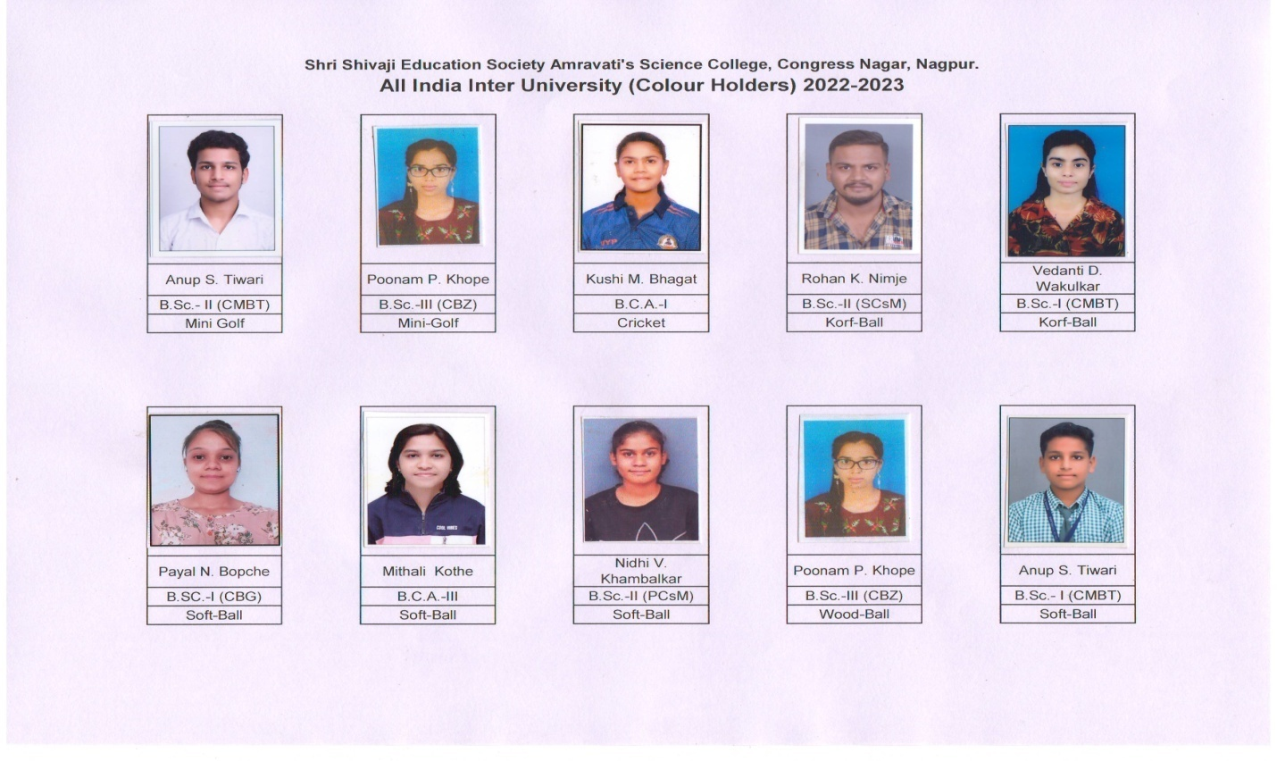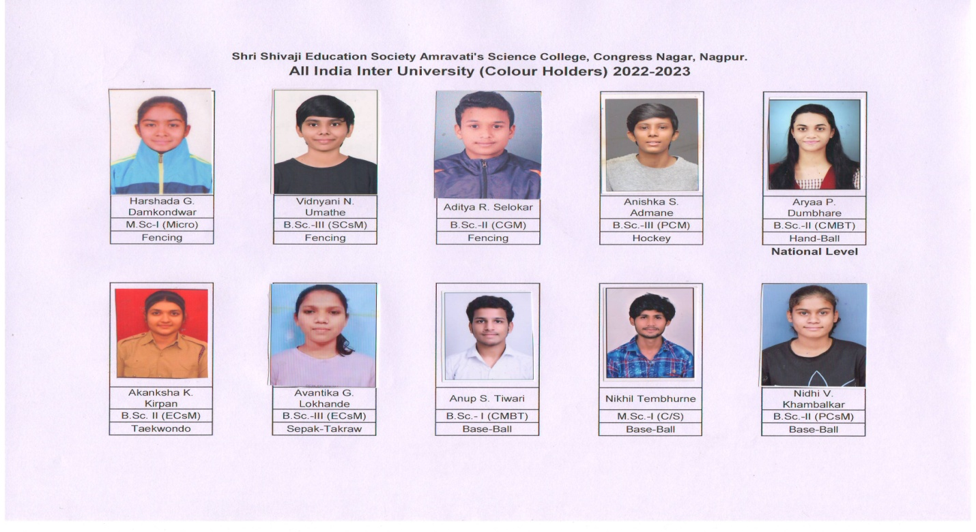

Head of Deptt
Phy. Edu. Department

